Resource efficiency – a human development report beyond “just another report”

Post-mission reflections on the next NHDR in Montenegro and the broader framework it fits

Background – the NHDR in the “Agenda for Change” context
UNDP is facing a transformational challenge. Corporately the organization is looking for new operational and funding modalities so that it could continue its human poverty oriented work in the tight resource constraints (that will be getting tighter further). A major element in that process might be returning to UNDP’s core mission – promoting human development. Nominally we have always being doing that but rarely managed to go beyond publishing NHDRs and advocating for human development. The NHDRs with their almost 20-years history clearly outline what needs to be done (human centered development policies) but we are still short of answering how it can be achieved, what human development means, how human driven responses differ from other development blueprints, why our responses are better and how they can be implemented.
The next NHDR in Montenegro provides a unique opportunity in that regard. It will be devoted to the issue of resource efficiency and might be shaping up as a strategic opportunity in at least three areas:
- influencing the policy debate on the issue of resource efficiency (and sustainability of development) in the country,
- providing a natural link between UNDP corporate agenda and EC accession process (shaping up the national agenda) and
- testing some approaches to the NHDR process and positioning human development explicitly at the core of the country programming infrastructure of the office.
Those three dimensions make the challenge of the next report well beyond “drafting and launching a decent document”. The future NHDR has the potential of influencing the corporate approach to human development and in the long run – help asking a number of crucial questions on the future mandate of UNDP in the region.
Thus it would be important to keep in mind the broader picture – the corporate dimensions and the need of “reinventing” of human development in UNDP’s daily work – when preparing thius particular NHDR.

The process
Given the three-dimensional nature of the context in which the document would fit, the process of the NHDR elaboration should be multidimensional as well. The individual dimensions and the related challenges need to be identified and clearly spelled out from the outset so that the stakeholders involved have the broader picture and the awareness of how the individual actions fit into it. Those stakeholders include not just the “usual suspects” (NHDR drafting team and the respective government and civil society partners). They include (or at least should include) most of the program staff of the office involved in the country programming and substantive projects.
The elaboration of the NHDR will face two major challenges:
- Integrating the sector specific analysis with human development paradigm. This is a challenge typical for most reports with clear sector specific focus because two types of competencies are needed – deep sector-specific knowledge and awareness of the human development paradigm. What usually happens, the latter is added in a rush at the final stage of a report elaboration, when it’s often difficult to integrate in a consistent text. In the case of Montenegro, the two processes will run in parallel with a lead author dealing with the sector-specific dimensions and a human development expert the HD Advisor in BRC or other) adding the HD dimension. This pattern of work entails on-going involvement of the HD person and working in partnership. It is not difficult to achieve – if this working pattern is clearly articulated from the outset and reflected in the respective TORs.
- Including and integrating inputs from other relevant (and related) projects being implemented by UNDP Montenegro. Positioning the NHDR as an “overarching platform” that brings together (and benefits from) individual efforts and project outputs is a permanent challenge that is notoriously difficult to achieve. The NHDR process is usually seen as a separate activity – just “another project” – running in parallel to others. The best what is usually achieved is submitting boxes from the individual projects for the report. Given the fact that the report addresses issues that fall in the scope of at least four projects of the office, deliberate efforts need to be made to integrate them (the project teams and the project outputs) into the NHDR.
This multi-actor and multi-stakeholder structure of the process would make it more difficult to coordinate but would yield enormous benefits in the mid and long run:
- Costs reduction – instead of hiring external experts, the specialists working on the specific projects may contribute with substantive inputs
- Mutual enrichment – the teams working on the specific projects will not just contribute to the NHDR but will benefit from it as well at least in two ways:
  - Get better awareness and understanding of the human development paradigm and the human development dimensions of their work
  - Receive additional visibility of the results of their work

The complementary thematic areas and their contribution to the NSSD
The NHDR is seen as a natural contributor to the NSSD (both as a document and as implementing process). Informing the process of finalization of the NSSD and paving the way towards its future implementation appears as a major value added of the NHDR. The later will contribute high level technical expertise (coming from the sector-specific projects) matched but the broader human development context in which this expertise will receive additional weight and depth. The human development dimensions should be addressed at two levels – that of the HD outcomes of the individual interventions (and the NSSD implementation in general) and the HD determinants of the implementation (seen from the perspective of human resources, behavioural patterns etc. – the people that will be actually making the NSSD a reality). Thus the report addressing resource efficiency will have to address also the aspect of “human resources efficiency” – not in the economic sense of the term (improving productivity of the labour force) but in broader HD term. This entails addressing the issues of (a) what kind of human capital is needed for successful implementation of the NSSD and (b) what would be the human implications of the NSSD implementation. The link to human resources (and human capital is a natural bridge between the two NHDRs (the current one to be launched on 28 January and the new one).
The following thematic projects (reflecting individual thematic areas of the NHDR) seem appropriate to reflect in the future content of the latter:
- Road map for resource efficiency. This is a major building bloc of the NHDR that will provide a natural link to the NSSD. Apart from the road map itself, a major contribution to the NSSD will be the human dimensions of that map. It will be unique opportunity to introduce resource efficiency concept directly in a human development context, as “human development centred resource efficiency”. It will also provide practical tools for estimating and assessing the human development costs and benefits of following the path outlined in the various scenarios for achieving 20/20/20 objectives
- Environmental indicators. This area will provide a broad overview of the possible approaches to quantifying and monitoring environmental aspects of resource efficiency. The most important contribution to the NSSD will be the link between environmental indicators and human development indicators not the HDI per se). This would include also indicators for “sustainable human development”. The inputs from this component will be the awareness of how the former translate into human development outcomes.
- Biodiversity. This aspect is important to factor in in the context of “opportunity costs of development options”. Biodiversity loss is often the long-term price governments (and societies) pay for the short-term economic gains. Sometimes this price is inevitable. But in order to minimize it, the various choices need to be informed by solid analysis and data. The latter is supposed to come from this component. Its most important contribution to the NSSD will be the in-depth analysis of costs and benefits of the individual scenarios with biodiversity factored in.
- Ecosystem services. This dimension will provide the knowledge on (improve awareness of) the tangible but unrecorded benefits coming from the ecosystems. It should not go too far into the direction of “monetary approach” to the issue (putting a monetary price tag on the various “services”). The appropriate approach should be rooted in the human development paradigm and its fundamental assumption that not all important human development dimensions can be expressed in $$$ terms. This awareness – and the practical approaches to reflecting the environmental services in the broader “not-just-monetary” equation will be most important contribution to the NSSD.
- Sustainable energy for all. Apparently a narrow sector-specific area, this dimension will contribute to the overall debate on energy efficiency (an important aspect of resource efficiency), low carbon economy etc. The most important contribution to the NSSD will be examples of feasible approaches in regards energy efficiency.
- Low carbon tourism. This component (GEF funded) might serve the dual role – as a source of practical example of how resource efficiency might be improved ad as a general conceptual framework (the desired level of wellbeing can be achieved in various ways and low-carbon path can be one of them). Most probably it will also provide practical tools for costing and factoring in the environmental aspects in a broader development strategy and NSSD in particular.
One programmatic area that is not explicitly listed – but should be integrated into the NHDR process – is the micro-narratives pilots for monitoring people’s attitudes and perception of environmental issues. This is a new powerful approach integrating qualitative and quantitative methods. It combines strength of both “hard” statistics and “soft” stories. In essence, the approach consists in collection of big number of individual stories and “indexing” them by storytellers. Indexing micro-narratives allows to identify patterns in the stories—for instance do people of certain profession/age/sex might have different preferences, what could be the acceptable compromises with their daily convenience if they are facing the need to change their behavioural patterns etc. A separate micro-narrative pilot might serve as additional data source that at its first stage might provide important information for the NHDR and in the long run – could evolve into a system of on-going monitoring of the NSSD, or a sort of Early Warning System, identifying zones of failures or fading importance of certain issues.

The risks associated with the proposed structure
The benefits of the approach outlined below come at the cost of the (potentially) lower degree of “national ownership” of the report and of the process. The risk is serious but not unmanageable. The following aspects need to be taken into consideration:
- All the substantive projects outlined above are being implemented with national partners and are nationally-own. UNDP is serving as a coordinator and facilitator of those efforts. It helps develop - – and does not substitute – the national capacities. Involving the individual teams into the NHDR process is in fact further (additional) contribution to expanding those capacities.
- The NHDR process is not just demand-driven, but also partnership-driven. The report will be elaborated in partnership with the various institutional stakeholders to a degree going well beyond “consultation”.
- From managerial perspective, the national partners will be constituting the governance bodies of the project – Project Board and the Advisory Board.

Broader programmatic implications
The elaboration of the NHDR may turn into a pilot test case of how a UNDP office might structure its work around the issue of human development. Human development is UNDP’s corporate brand but it often falls victim of sector-defined interventions. Human development (that is supposed to be everywhere in our work – is effectively nowhere except in the NHDR (and even there it’s often degraded to the calculation of the HDI). Nominally the individual practices should be contributing to achieving human development outcomes but in reality they usually remain working in individual silos with human development expected to “materialize” automatically. This is a paradoxical reflection of the neoliberal mantra that “a rising tide lifts all boats” – in our case, the anticipation that success in sector-specific interventions would automatically improve the level of human development by the virtue of the very fact that those interventions are being implemented by UNDP.
The future NHDR might provide an alternative to that practice. Involving the important activities of the Office in the elaboration of the report, it might shift the paradigm and revert the sequence – introducing the human development dimensions to individual projects’ work. This might be an important contribution to the corporate Agenda for change.

The link to “beyond 2015” agenda”
Given its topic, the report has explicit link to “post 2015” agenda. It means the process of the NHDR elaboration should be at least coordinated with other related activities – namely the “post 2015” country consultations and the work on the indicators for SDGs. The NHDR in Montenegro might be a pilot in several respects:
- The feasibility of the proposed indicators in regards statistical methods and data collection. In that regard the indicators that are being discussed (including the ideas for “sustainability adjusted HDI” and other development indicators) can be calculated for Montenegro and tested in “real time” reporting. The timing of the NHDR is optimal in that regard coinciding with the timing of the next GHDR that will be devoted to post-2015 issues
- As additional area of complementarity between the NHDR and the “post-2015” processes might be the pilot on “Telling the story on Future we want (Post-2015 consultations)” that is being considered by BRC HD and KM teams (concept attached in the annex).
- post MDG it might be

Managerial arrangements
Individual roles of the major actors involved should be clearly defined with the multidimensionality of the process in mind. Namely:
- The national consultant should have the role of coordinating the substantive inputs and providing the technical expertise on the primary topic of the report
- HD advisor (BRC) should be responsible for ensuring that human development aspects are mainstreamed through the entire report (and not just added as some stand-alone components). For that purpose, together with the national Consultant, he should
  - Conduct a one-day training for the program staff of the office involved in projects that are relevant to the topic of the report
  - Assist the program staff in identifying possible inputs for the NHDR
  - Provide guidance of the drafting of the inputs
- The individual project teams should be encouraged to look “out of the box” of their individual projects and look for opportunities for mainstreaming the results of the individual interventions in broader human development targeted interventions. For that purpose a half-day mini-retreat might be useful to have once the first drafts of the individual contributions are in place
- The NHDR project coordinator might be recording all the stages and steps from process-learning perspective so that if successful (as we hope it will be), the process of “NHDR elaboration as human development mainstreaming exercise” is conceptualized in set of guidelines replicable in other country contexts.

Conclusions and next steps
We have all the grounds to say “This time is different” – at least it should be different. The process of the NHDR 2013 in Montenegro elaboration has all the chances of becoming a game-changer for UNDP corporately. Given the fact that the organization is at a crossroads, it is worth the effort of going beyond “just another report”.
The next steps in that regard might include:
- Selection of the national Coordinator
- Overview of the programmatic portfolio of the office from the “human development mainstreaming” perspective
- Training for the NHDR and individual project teams
- Discussions with the government and civil society partners on how the report might fit into the existing and future national strategies and policies
- Investigating the opportunity of the proposed pilots (the SHDI calculation and application, the micro-narratives based “Telling the story on Future we want” monitoring system etc.).

Annex
Telling the story on Future we want (Post-2015 consultations)
Draft 2.1, for internal consultations. Please do not disseminate or quote. January 18, 2013
Prepared by Mihail Peleah (Mihail.peleah@undp.org), Human Development Programme and Research Officer, UNDP BRC

Scope of undertaking:
Advocacy
Monitoring
Research
- understand and identify development and sustainability (and their combination) challenges people face with;
- engage people in debates of post-2015 sustainable development goals
- check the boundaries of possible solutions
- sense relative value (weights) a of prospective Sustainable Human Development Index.

Issue: The objective of the country consultations is to stimulate an inclusive debate on a post-2015 development agenda by providing an analytical base, inputs and ideas that
- build a shared global vision on ‘The Future We Want‘, with clear recommendations for governments, civil society and broad stakeholders;
- amplify the voices of the poor and other marginalized groups in formal negotiation processes; and
- influence the intergovernmental processes so that they align with the aspirations of civil society for a post-2015 agenda.
Points (a) and (b) relate to the Research part of story collection exercise, point (c) relates to Advocacy side. Previously adopted Millennium Development Goals were widely criticized for non-inclusive process of development and application.

Sample: Population of countries. Initially, stories could be collected in countries of region, which later on could be expanded to other countries. If the pilot in the region is successful and depending on the interest, the undertaking has the potential of expanding to global scale ongoing monitoring system. Taking into account on-going consultations, focus of pilot could be on non-covered countries, for instance, New Member States.

Organization and partnership: This would depend on a number of (still) open questions:
- Shall stories collection be included in the national consultations?
- Can we involve schools and how?
- What might be the role of the Human Development and MDG focal points?
- What could be the role of “civic journalism” components?
- Other unknowns…
Possible options: (i) Stories collection could be included in national consultations. (ii) Another point for stories collection could be “MyWorld2015” website (http://www.myworld2015.org), which currently collects just priorities of people. (iii) Taking into account forward looking and support mobilization nature of consultations it could be important to involve schools, using the pupils to collect from their communities as field ethnographers themselves.

Capture process and questions:
1. Prompting Stone game. X-axis: Economy / Productive, Society, Environment. Y-axis: Flourishing (+) Depleted (–). Stones to position: (1) We are here now; (2) We should get there by 2030; (3) Government should focus here; (4) I could contribute here; (4) This point is hopeless.
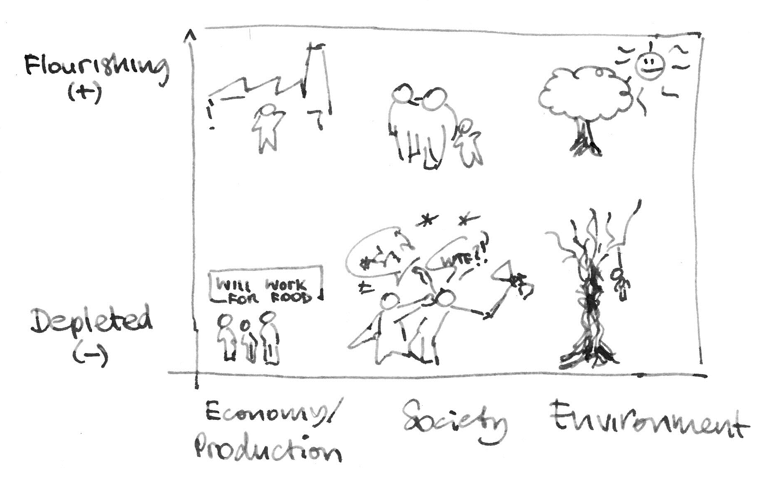

2. Tell the story
- Fifty years from now, you are invited to lecture students about the world in 2013. What examples or stories would you share?
- Imagine you have been asked to speak to contribute to a United Nations debate on how the world has (or has not) changed in the past 100 years. What stories of yours or your family’s would you tell them?
- For schoolchildren collecting from their communities:

Find at least one story for each of the boxes in the following table:
 | People you think are leaders | Family members of different generations | Peers and people of your own age
Stories of the past that must not be forgotten
Stories from now that tell other people who we are
Hopes and dreams for the future

3. Indexing
A. Country—by interview design. In case of website—ask place of residence.
B. Triads
Concept/question | Upper | Left | Right
Temporalisation: The lesson of this story applies to | Present | Past | Future
Who could have the greatest impact on events in this story? | International | National | Local
In this story, what do people value? | Ability to afford things | Ability to affect decision making | Ability to make choices about their life
People in story are happy (unhappy) because they can (cannot)… | Afford consumption | Affect decision making | Live the life they value
People in the story cared about | Their environment | Their heritage and community | Their personal needs
People in the story give priority to… | Their personal current needs [ development, equity] | Needs of their grand-children [ sustainability] | Spiritual development [ third way?]
In the story, people acted this way because? | Just did it, no reason | On unchanging principles | Adapted to realities of situation
Hierarchy and justice: The attitude of people in the story is | Everyone should be treated the same | Some people are worth more | Diversity is a good thing
People in this story are | In control (Heroes) | Suffering victims | Side observers
Possible other issues (but you know best)
In the story, people lacked | Resources | Knowledge/Skills | Connections
In the story, people were | Considered in their actions | Missing valuable opportunities | Using unsustainable resources

C. Dyads
Concept/question | Left | Right
The situation in this story is | Eternal, unchanging | Highly volatile, forever uncertain
In the story, people were | Isolated and alone | Crowded and claustrophobic

D. Multiple Choice Questions
Question | Options
Emotional load of the story | [Standard options]
Who should listen your story? | [_] International Organizations (UN, etc)  [_] Leaders of Global Powers (China, EU, Russia, USA)  [_] Your country national Government  [_] Your local Government  [_] Your neighbours  [_] Your family  [_] Your grandchilren
Are you familiar with either of this documents or concepts? | [_] Millennium Development Goals  [_] Sustainable Development Goals  [_] Your country Human Development Report  [_] Global Sustainable Humanity Development Initiative (fake)  [_] Global Human Development Report  [_] Agenda 21  [_] Rio and Rio+20 Conferences  [_] Country PRSP or NDP

E. Indexing Stone Game
Option 1. X-Axis: Me, My Family, Society. Y-scale: Vital (+), Useful (–).
Option 2. X-Axis: Working, Not-working (=not producing results). Y-scale: Vital / Essential? (+), Non-vital / Luxury? (–).
Option 3. X-Axis: Me, My grandchildren. Y-scale: Vital / Essential? (+), Non-vital / Luxury? (–).
Stones to locate: Health, Education (Knowledge), Decent standards of living, Environment, Agency (Ability to decide what kind of life I would like to live)

F. Demographic Questions
- Age group
- Gender
- Education
- Employment
  - self-assessment (I am … worker / farmer / pensioner / unemployed / student …)
  - objective criteria (last week I was doing the following: working / processing land / studying / etc.)
- Position in the society / relative poverty
  - If whole society would be a scale with 10 steps numbered from 1 (lowest) to 10 (highest), on which step would your family be?
  - How would you estimate your incomes?
    - We don’t have enough money for food
    - We have money just for food
    - We can afford normal life, but not more expensive items
    - We can afford more expensive items
    - We have no limitations

Timetable:
 | Dec’12 | Jan’13 |  | Feb |  | Mar | Apr | May | Jun | Jul
Design
Test: Respondent
Test: Partners
Set up
Capture
Report
Finalization
NB: Post-2015 Debates
Country consultations
Final country reports to HLP
Event to present consultations results
Country consultations to provide inputs for UNDG’s discussions with Member States

Risks, issues, and points for further consideration:
- Check the status and schedule of country consultations?
- How to organize tradeoff, what-would-you-sacrifice question?
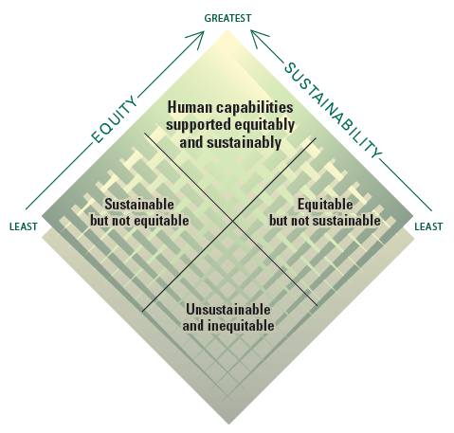
HDR2011: The cover diagram symbolizes how different policies can have different implications for sustainability and equity. Whenever available, we should prefer solutions that are good for the environment while also promoting equity and human development. Pursuing sustainability and equity jointly does not require that they be mutually reinforcing. In many instances they will not be. Sometimes the most feasible alternative involves trade-offs between sustainability and equity and requires explicit and careful consideration. No trade-off is isolated from a society’s structural and institutional conditions, and so we must address the underlying constraints and identify positive synergies between sustainability and equity. This Report is aimed not only at finding positive synergies but also at identifying ways to build them.

Guidelines for Country Dialogues on Post-2015 Development Agenda suggests the following reasons for country consultations (for all of them micro-narratives are relevant): - To broaden the analytical base for global goals - To support citizens from the Global South to actively engage in the discussions towards a post-2015 development agenda, so as to potentially influence both their own government’s positions and the intergovernmental process - To ensure people’s “active, free and meaningful participation in development” (GA Declaration on the Right to Development, 1986) - To create avenues through which voices of the marginalized can be amplified and acted upon - To support countries in exploring innovative mechanisms, and strengthening existing mechanisms, to draw on people’s skills, experiences and ideas when developing and implementing policies that affect them (UNDG. Post-2015 Development Agenda: Guidelines for Country Dialogues. http://www.undg.org/index.cfm?P=1627)
Global site http://futurewewant.org/ was set up to promote communication on the issues of post-2015 agenda. However, at the current stage, it only aggregates and disseminated materials from social networks (grand narratives), not people stories (micro-narratives), and no indexing of ‘stories’ is employed so far. Affiliated site MyGreenDream http://green-dream.co.uk/ captures “green dreams”, but, again, it lacks indexing and other desirable functionalities.
The UNDG is funding and conducting national consultations in Albania, Armenia, Kosovo, Montenegro, Moldova, Kazakhstan, Tajikistan, Turkmenistan, Azerbaijan, Belarus, Serbia, and Kyrgyzstan.
In Europe and Central Asia the following countries are involved in consultations: Armenia, Kazakhstan, Moldova, Tajikistan, Turkey, and Ukraine. More details, including on other regions are available on-line: http://www.beyond2015.org/un-50-country-consultations
In Europe and Central Asia the following countries are involved in consultations: Albania, Armenia, Kosovo, Montenegro, Moldova, Kazakhstan, Tajikistan, Turkmenistan, Azerbaijan, Belarus, Serbia, and KyrgyzstanArmenia, Kazakhstan, Moldova, Tajikistan, Turkey, and Ukraine. More details, including on other regions are available on-line: http://www.beyond2015.org/un-50-country-consultations
As presented in UNDG. Post-2015 Development Agenda: Guidelines for Country Dialogues. http://www.undg.org/index.cfm?P=1627

